**Year 7 HASS 2024- Economics and Business**

**Assessment 1 – Case Study (7%)**

|  |  |
| --- | --- |
| **HUMANITIES & SOCIAL SCIENCES ASSESSMENT TASK** | |
| **Year level** | 7 |
| **Subject** | Economics & Business |
| **Title of task** | Assessment 3: Case Study – Impact of COVID on businesses. |
| **Weighting** | 7 % |
| **Description of task** | This assessment has two parts:  **Part A (5%):** Students will spend *two lessons in class* using a provided graphic organiser to make notes based on a news article.  **Part B (2%):** Students will complete an in-class validation (*one lesson*) with short answer questions based on the article and the way that producers must respond to the demands of consumers. They will be allowed their note-taking sheet for this. |
| **Suggested time** | * 3 lessons in class |
| **DOCUMENTATION** | |
| **Documentation** | * Copy of news article * Note-taking template (A3) * Validation |
| **TEACHER FEEDBACK** | |
| **MARK:**  _____/38 | |

## Background Information

The coronavirus (or COVID 19) pandemic forced a number of changes in consumer behaviour, and businesses were compelled to respond quickly to maintain their market share and remain viable. The following businesses have been impacted by the restrictions placed on society due to the coronavirus pandemic and have been required to respond to changes in consumer demand.

* Teleconferencing services
* Food delivery services
* DIY suppliers
* Education and health services
* Food suppliers e.g. cafés and restaurants

## Instructions:

*Note: You will have two lessons in class to complete this part of the task.*

1. Before reading the article, make notes on your A3 note-taking sheet on how you think the listed industry has been shaped by the Coronavirus
2. Read the ABC news article titled *‘Coronavirus shifts consumer behaviour and helps some businesses boom’* by Nassim Khadem. A copy is provided in this booklet for you (Pg 3). Take notes on your A3 sheet based on how different technological advancements and COVID-19 has impacted the listed industry.

## Part A: Marking Key

|  |  |  |  |  |  |
| --- | --- | --- | --- | --- | --- |
|  | **3** | **2** | **1** | **0** | **Subtotal** |
| **Before Reading**  **(Per Section)** | 3 marks detailed notes | 2 marks for listing and outlining | 1 mark limited notes | No notes are submitted (0) | /12 |
| **After Reading** | **4-5** | **2-3** | **1** | **0** | **Subtotal** |
| **Videoconferencing** | Detailed notes, Uses supporting evidence from the source such as statistics, quotes and examples of businesses. | Adequate notes, Uses mostly relevant supporting evidence from the source such as statistics, | Limited notes, Uses some evidence the source, however there are some lapses in relevancy or accuracy. | No evidence is provided (0) | /5 |
| **Food Delivery & Restaurants** | Detailed notes, Uses supporting evidence from the source such as statistics, quotes and examples of businesses. | Adequate notes, Uses mostly relevant supporting evidence from the source such as statistics, | Limited notes, Uses some evidence the source, however there are some lapses in relevancy or accuracy. | No evidence is provided (0) | /5 |
| **DIY (Bunnings etc)** | Detailed notes, Uses supporting evidence from the source such as statistics, quotes and examples of businesses. | Adequate notes, Uses mostly relevant supporting evidence from the source such as statistics, | Limited notes, Uses some evidence the source, however there are some lapses in relevancy or accuracy. | No evidence is provided (0) | /5 |
| **Beauty and Books** | Detailed notes, Uses supporting evidence from the source such as statistics, quotes and examples of businesses. | Adequate notes, Uses mostly relevant supporting evidence from the source such as statistics, | Limited notes, Uses some evidence the source, however there are some lapses in relevancy or accuracy. | No evidence is provided (0) | /5 |
|  | **5-6** | **3-4** | **1-2** | **0** | **Subtotal** |
| **PMI** | Comprehensive detail is used in each section of the PMI chart, which relates clearly to the task and the key areas. | Less comprehensive reference to key areas. Some sections are incomplete or not finished, with sections missing, including basic information on task and/or topic. | Presents a generalised plan and/or limited chart. Limited references are made to key areas. Sections are missed. | No PMI Chart Submitted | /6 |

**Total Score:** ________ / 38

News Article

**Adapted from:** Khadem, N. (April 2020). Coronavirus shifts consumer behaviour and helps some businesses boom. *ABC News.* <https://www.abc.net.au/news/2020-04-06/coronavirus-shifts-consumer-behaviour-and-helps-businesses-boom/12119508>

**Coronavirus shifts consumer behaviour and helps some businesses boom**

Social distancing measures and lockdowns introduced in response to the coronavirus pandemic have forced everyone to rethink their everyday interactions.

It may permanently change the way we live and work, according to Australian business leaders.

Videoconferencing services like Zoom and Skype, food delivery services like Uber Eats and Deliveroo, and businesses like Bunnings now see the future differently. They are some examples of the businesses which have not just survived the biggest health and economic catastrophe of the century, but are booming.

However, the pandemic has also raised some new questions about privacy and security. If more of us are online and using apps to do everything from birthday parties, weddings, funerals and business board meetings, what responsibilities do companies have to protect our information?

**Demand for videoconferencing will continue to grow rapidly**

Zoom, a free video conferencing app, has had a big uptake in consumers and has had to advise consumers of how their information will be protected. After some cases of so-called ‘Zoombombing’ – where hackers or trolls hijack a public video call- the company’s security and privacy protections have come into question. One of the company’s leaders, Michael Chetner, says the company takes security and privacy seriously and complies with all of the local laws wherever it operates.

He said that technology is now a requirement, not a just something on people’s wish list. A digital transformation is occurring.

In Australia there has been more demand for services in rural and regional areas around education and health. Mr Chetner said that the need for Zoom will only continue to increase with educators teaching their students and health professionals how to deliver e-health services.

“As of the end of December last year, the maximum number of Zoom participants was about 10 million, but now it’s up to more than 200 million per day”.

**Online food delivery soars**

The introduction of social distancing measures and closure of businesses has hit the café and restaurant industry especially hard. But companies like UberEats and Deliveroo are now seeing many temporarily shut-down restaurants move onto their platform, looking for ways to increase their digital business. The boss of Deliveroo said that in the week after bans were introduced, the 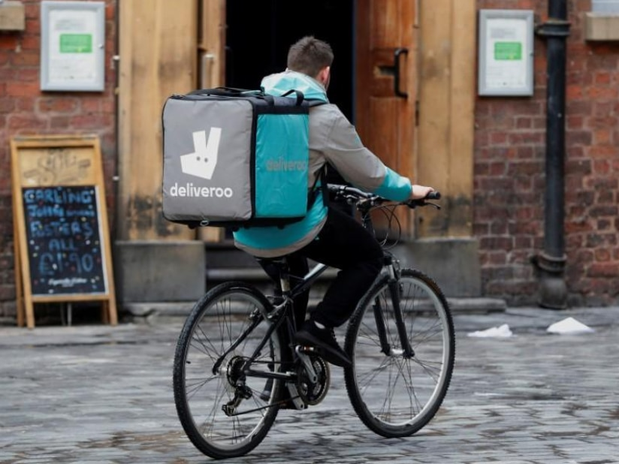company saw an additional 1700 restaurants join. This includes higher-end restaurants, and those in which pre-coronavirus had long lines of customers waiting outside their doors, such as Melbourne’s Chin Chin.

Mr McManus says there has also been a growth in the number of new customers ordering through the app, as well as in the volume of deliveries. He is beginning to question whether consumer behaviour is now forever changed, however added that Australians love dining out with friends and family, and that would likely always be the case.

**Retail sector in transition**

The retail industry, however, may have permanently changed.

Bunnings managing director Mike Schneider says that the retailer has seen demand like never before for goods as more Australians work and spend time at home.

He says there has been a huge wave of people purchasing supplies to build home offices and home classrooms. But there has also been a steady strong demand for cleaning products, seedlings and general garden supplies.

The company’s online marketplace has also been booming, with people purchasing gym equipment and various home fittings and furnishings. In March there were about 30 million visits to the Bunnings website. More customers are now purchasing goods through the website and also paying for online delivery.

Schneider said “our patterns of living are going to change, and if that changes then what you buy and how you buy it changes”.

**Demand for online goods from beauty to books**

Businesses that were already operating online have been winners in this crisis. Kate Morris, founder of adorebeauty.com.au, says her Melbourne-based business has never seen such a leap in demand for online beauty and skincare products. This is thanks to a huge spike in demand for products including hand wash, sanitiser, soap and skincare.

Since beauty salons closed and people stopped going to hairdressers, Ms Morris says sales of shampoo and conditioners, as well as facemasks, have also soared.

Australian online bookstore Booktopia’s deputy CEO Wayne Baskin says they are hitting their targets because demand for some books has gone up, mostly fiction.